Michael G Menard, Brandon N Collins, Jacob D Jones

Keep Kids alive map users manual

Keep Kids Alive Map User’s Manual

| Table of Contents |

1. General Information - 2
   1. System Overview - 2
   2. Organization of the manual – 2
2. Submitting data - 3

2.1 The Submission Page - 3

2.2 Using the Page - 3

3.0 Viewing the Data - 4

3.1 The Map API - 4

3.2 The Raw Data Table -5

4.0 Contacting the Owner of the Application - 6

4.1 The Contact Page and the Form - 6

5.0 Navigating the Application - 7

5.1 The Navigation Menu - 7

1. General Information

This section of the Manual will provide general information regarding the system, including its uses and how to use the interactive portions of the system.

* 1. System Overview

The Keep Kids Alive Map is an application which allows the collection of information regarding minor traffic infractions. It provides a simple, one button press submission method for several major traffic infractions, as well as an interactive map created with the purpose of visualizing the data. It also provides a table of submitted data for more in-depth analysis. All data collected is saved to a database. The app was designed with mobile devices in mind, and some parts of its functionality may not work properly on desktop systems.

* 1. Organization of the Manual

This manual consists of several different sections: submitting data, viewing data, submitting comments, and a general navigation guide. Please note that this document does not contain detailed descriptions of the script behind the application. Please consult the Systems administration document for further details regarding the inner workings of the application.

Submitting data gives an overview of the submittal page and how to use it.

Viewing data provides an explanation of how to view the data in the application and how to interact with the map API.

Submitting comments shows how to submit a message or comment through the contact form on the contact page.

The general navigation guide gives a brief overview of each of the pages found within the application and how to flip between the pages.

1. Submitting Data

This section will detail how to use the application to submit data into the online database.

* 1. The Submission Page

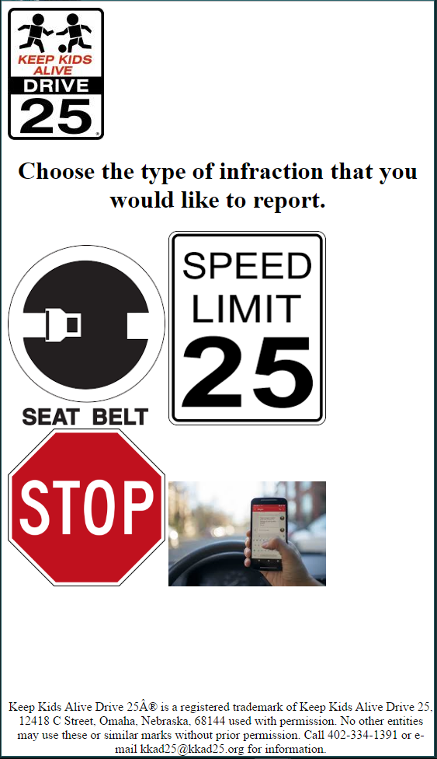

Button for submitting infractions related to unbuckled seatbelts

Button for submitting infractions related to distracted driving

Button for submitting infractions related to speeding

Button for submitting infractions related to rolling stops.

* 1. Using the Page

The page above is our submittal form, simplified for ease of use on a mobile device. Click any one of the buttons outlined to send information regarding the nature of the infraction, your location, and the data and time of the incident. Do note that geolocation services must be turned on or the data you will encounter an error. There is no extra input, as the data collection is completely automated.

1. Viewing the Data

This section of the guide will provide an overview of the methods available to the user in viewing the data submitted by the application. There are two methods, a visual map of the data, detailed in 3.1, and a table full of the values from the actual database table, detailed in 3.2.

* 1. The Map API

The map is the main and more intuitive way of viewing the data collected by the application. It provides visual reference concerning the actual locations of the infractions, unlike the data table which provides raw latitudinal and longitudinal data for each point.

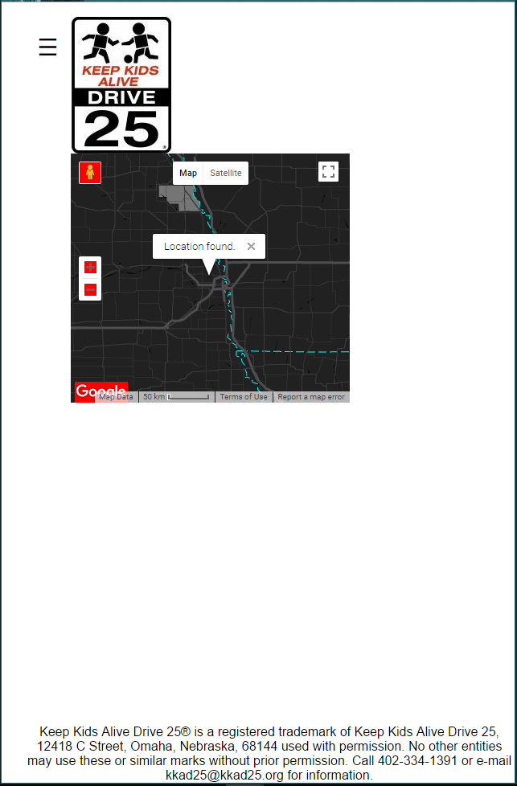

Full screen controls.

Zoom controls.

This map can be set to full screen using the full screen button, and you can zoom or un-zoom the map using the zoom controls. The three lines on the top is the main navigation menu. For further details regarding the navigation menu, please see section 5.1.

* 1. Raw Data Table

The application also provides a data table containing the raw data from the database. This provides specific coordinates for each of the infractions and allows for a more in-depth analysis of the data. 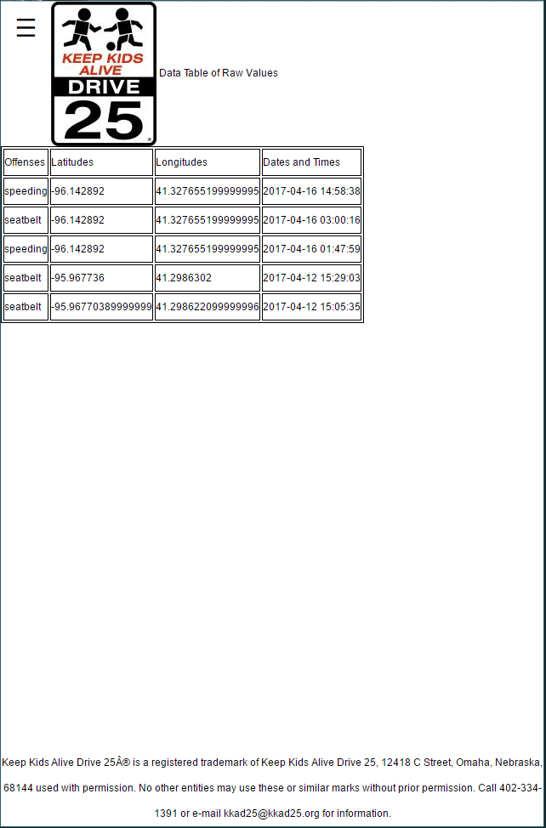

Column detailing the date and time related to each submittal.

Column detailing the longitude related to each submittal.

Column detailing the offense related to each submittal.

Column detailing the latitude related to each submittal.

1. Contacting the Owner of the Application

This section will detail how to contact the person in control of the application. Using a simple form, the contact page will send a message to the person controlling the appliaction, and give them your name and email adress should they want to contact you in return. This feature can be used to submit comments or complaints regarding the application.

* 1. The Contact Page and the Form

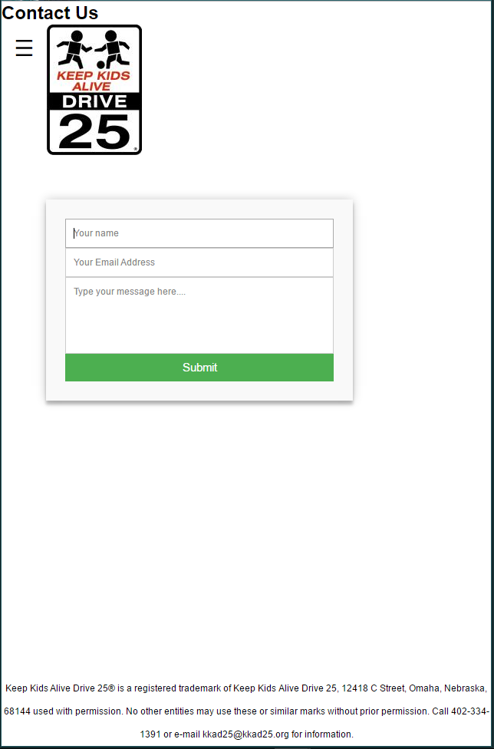

Submittal form.

The form on this page take a total of three pieces of information, your name, your email, and a message that you wish to send to the owner of the app. Please note that all fields need to be filled in order for the submission to happen and that you must use a valid email adress when entering an email.

1. Navigating the Application

This section will detail how to navigate the various pages of the application using the navigation menu.

* 1. The Navigation Menu

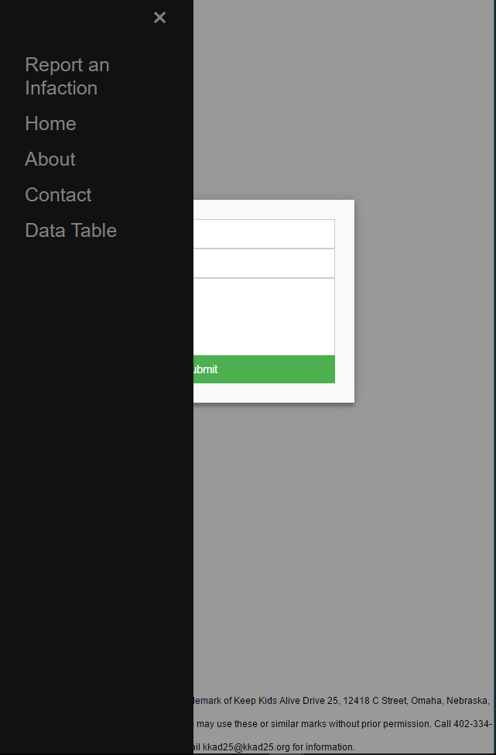

The menu shown here is available by clicking the button in the upper left hand corner of any of the pages. It allows you to flip back and forth between the various pages of the application by clicking the names of the pages.